RESOLUTION NO.__________

RE: CERTIFICATE OF APPROPRIATENESS UNDER THE
PROVISIONS OF THE ACT OF THE PENNSYLVANIA
LEGISLATURE 1961, JUNE 13, P.L. 282 (53
SECTION 8004) AND BETHLEHEM ORDINANCE NO.
3952 AS AMENDED.

WHEREAS, it is proposed to install signs on the exterior of the building at 702 E Fourth Street.

NOW, THEREFORE, BE IT RESOLVED by the Council of the City of Bethlehem that a Certificate of Appropriateness is hereby granted for the work.

Sponsored by: (s)

(s)

ADOPTED BY COUNCIL THIS DAY OF

(s)
President of Council

ATTEST:

(s)
City Clerk

HISTORIC CONSERVATION COMMISSION

CASE # 548 – It is proposed to install signs on the exterior of the building at 702 E Fourth Street
OWNER/APPLICANT: John Gross / David Delos Santos

The Commission upon motion by Mr. Lader seconded by Mr. Evans adopted the proposal that City Council issue a Certificate of Appropriateness for the proposed work described herein:
- The proposal to install signs on the exterior of the building at 702 E Fourth Street was presented by David Delos Santos.
- The proposed internally illuminated box signs were not historically appropriate and the Historic Conservation Commission recommended two options for the applicant.
- Option 1: Vinyl lettering placed in the upper part of the display windows closest to the doors on the north and west to read “Antillana Meat Market”. In addition to the vinyl lettering the sign may include a neon logo appropriate to the meat market use and similar to the proposed logo of a man with a cleaver.
- Option 2: Install a new blade sign in the same location as the existing metal frame from an old sign at the corner of the building. The new sign is to be fabricated of a composite sign material such as HDU (High Density Urethane). The blade sign may be illuminated with externally mounted spot lights. In addition to the blade sign vinyl lettering may be placed in the display windows as described in Option 1. This option would not include the neon logo sign.
- For both sign options, serif style lettering is recommended.
- The applicant must work with the Historic Officer to finalize the design of the new sign.
- The proposed motion was unanimously approved.

CU: cu
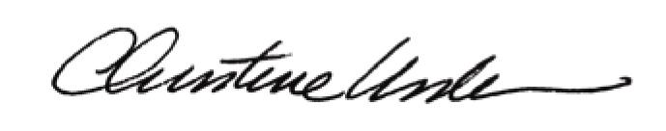

By:

Date of Meeting: May 18, 2015 Title: Historic Officer

